Fellow Patrollers,

As always, thank you in advance for the amazing work you do on-hill and all around [resort] each and every shift. Our patrol’s efforts are critical to [resort’s] success.

As you’re probably aware, our patrol recently experienced a critical, on-hill call that resulted in significant injuries to the patient [patients, guests, etc.]. As you know, calls like these can potentially result in natural, but negative, post incident reactions for the first responders involved. It’s extremely important to remember that Critical Incident Stress (CIS) is the normal reaction of a normal person to a highly abnormal situation.

I want to remind us all how to recognize the impact of CIS on our fellow patrollers, and guide anyone who may be experiencing normal, post-incident stress injury towards trained resources to help. As medical professionals, all of you know from the patient assessment model that signs and symptoms will lead you toward appropriate interventions. Among each other, here are some basic signs and symptoms for self-assessment and assessing your fellow patrollers for potential Critical Incident Stress Injury or Impact (CISI):

COGNITIVE EMOTIONAL BEHAVIORAL
Confusion Anxiety Change in activity level
Poor attention Guilt Loss of sleep
Poor decisions Grief Withdrawal
Heightened or lowered alertness Denial Emotional outburst
Poor concentration Irritability Hypervigilance
Memory problems

First and foremost, if you believe yourself or a colleague may be suffering from CIS, please DO NOT take upon yourself to intervene. It’s very important to me that our patrollers receive care from trained providers for the sake of both their own health and the health of the patrol. I ask you to please alert me or other patrol leadership so that we may take the appropriate steps to ensure proper care. In our region, our primary CIS resource is [region CISM contact].

Thank you for all that you do every day. I attach for your reference the CISM presentation that was given at this year’s refresher, and as always, I am available for further discussion. More CISM information specifically for patrollers can is at https://www.nspeast.org/safety/stressawareness, on your smartphone at bit.ly/nspcis or scan:
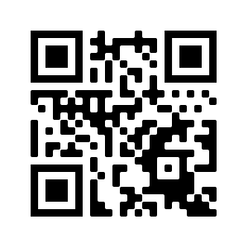
We care deeply about you and your loved ones,

Patrol Director

